**Js Quest04**

Remember to git add && git commit && git push each exercise!

We will execute your function with our test(s), please DO NOT PROVIDE ANY TEST(S) in your file

For each exercise, you will have to create a folder and in this folder, you will have additional files that contain your work. Folder names are provided at the beginning of each exercise under submit directory and specific file names for each exercise are also provided at the beginning of each exercise under submit file(s).

**Introduction**

From Hollywood's movies: "Give me a pdf, so I will connect my ssh to my RSA and I will be able to access the md5."

Most of the computer on earth are not running any Graphical User Interface (GUI) and the closest thing we have from it, is the terminal.

But more important, you can do more things with the terminal than with the GUI. We will pass some time here, to write some scripts.

At the end of the bootcamp you will be one of us :-)

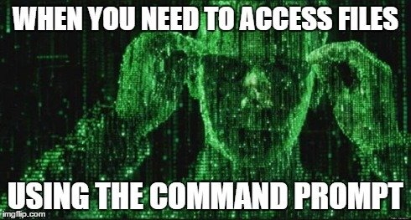

| **Js Quest04** | **My First Script** |
| --- | --- |
| Submit directory | ex00 |
| Submit file | my_first_script.js |

**Description**

Write your first script, printing Hello World!. Create a file my_first_script.js. Add a printing function (see tips)

**Example 00 (In Javascript)**

$>node my_first_script.js

Hello World!

$>

**Example 01 (In Python)**

$>python my_first_script.py

Hello World!

$>

**Example 02 (In Ruby)**

$>ruby my_first_script.rb

Hello World!

$>

*Tip* (In Javascript) It will contain console.log("Hello World!")

| **Js Quest04** | **My Multiple Variables Multiple Type** |
| --- | --- |
| Submit directory | ex01 |
| Submit file | my_multiple_variables_multiple_type.js |

**Description**

Replace/Complete the following code. Create multiple variables with (if needed) the right type. (XX is what you need to replace)

**Function prototype (javascript)**

XX = 34;

XX = "Luke";

XX = ',';

console.log("Hello " + my_name + my_comma + " I'm "+ my_age + " years old.");

**Example 00**

Input:

Output: Hello Luke, I'm 34 years old.

Return Value: nil

| **Js Quest04** | **My First If Multiple Conditions** |
| --- | --- |
| Submit directory | ex02 |
| Submit file | my_first_if_multiple_conditions.js |

**Description**

if statement is linked to else and writing the right condition can be quite complicated :D.

Replace/Complete the following code. (XX is what you need to replace)

**Function prototype (javascript)**

a = 10

b = 9

c = 11

d = 10

y = 9

z = 11

if (XX) {

console.log("a is bigger than b AND smaller than c AND equal to d");

}

if (XX) {

console.log("z OR y are bigger than a");

}

**Example 00**

Input:

Output: a is bigger than b AND smaller than c AND equal to d

z OR y are bigger than a

Return Value: nil

| **Js Quest04** | **My First Function** |
| --- | --- |
| Submit directory | ex03 |
| Submit file | my_first_function.js |

**Description**

Writing syntax of code is the small visible part of the Code Iceberg. Software Architecture (Design Software) are really the deal.

In order to "organize" your code function are the key. Let's dive in!

Replace/Complete the following code. (XX is what you need to replace)

**Function prototype (javascript)**

// Following XXXXXX will be a function that will print using console.log("my_first_function")

XXXXXX

XXXXXX

XXXXXX

my_first_function();

**Example 00**

Input:

Output: my_first_function

Return Value: nil